Aim- Write python programs to understand

a) Different List and Tuple operations using Built-in functions

b) Built-in Set and String functions

c) Basic Array operations on 1-D and Multidimensional arrays using Numpy

d) Implementing User defined and Anonymous Functions

LIST:

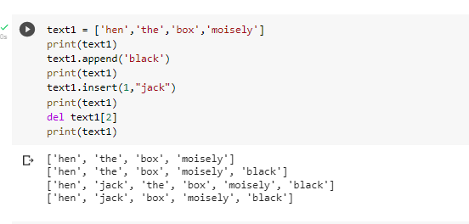

TUPLE:

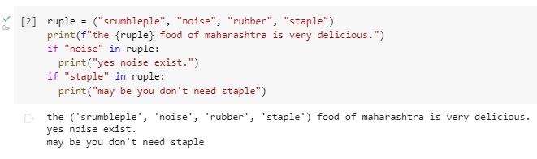

DICTIONARY

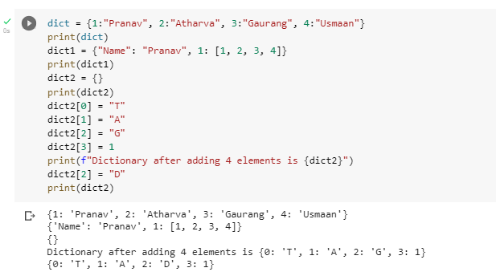

B)Built- in set and String Functions:

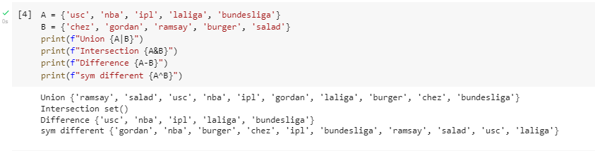

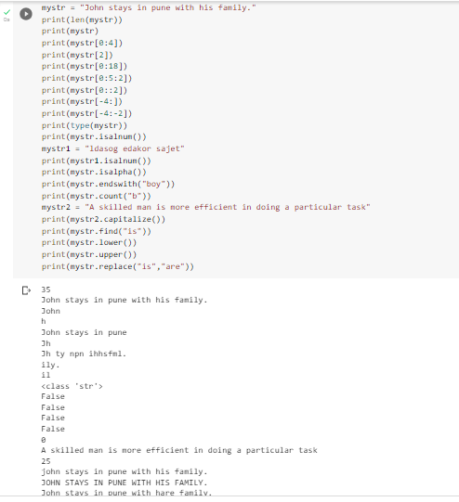

C)Basicarrayoperationson1-DandMultidimensionalarraysusingNumpy

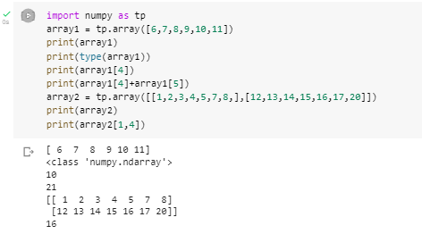

D) Implementing user defined and anonymous functions

